J a n n a



A H r n d t

STUDENT PORTFOLIO

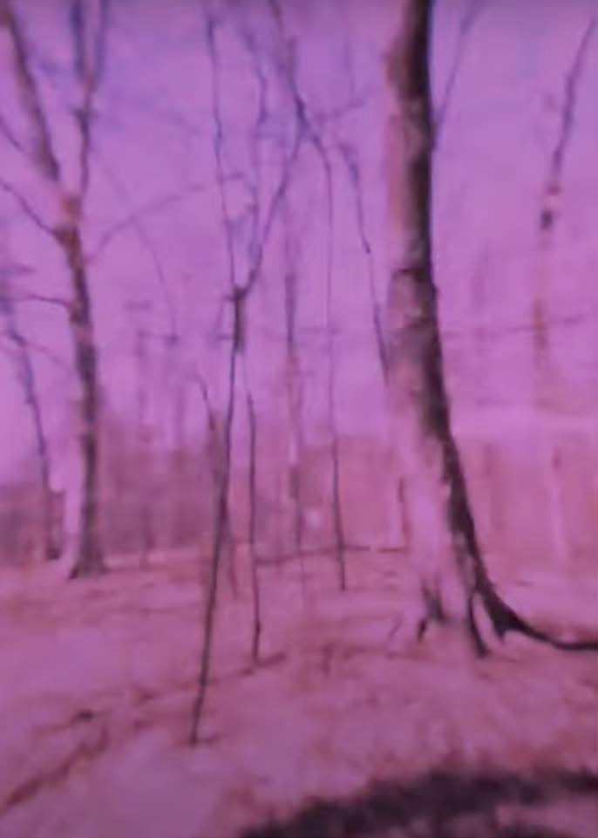

# Video Art

Playlist Here: https://youtube.com/playlist?list=PL0qdYFhePtBA_ knw2kkfSIxyogbhsPx94

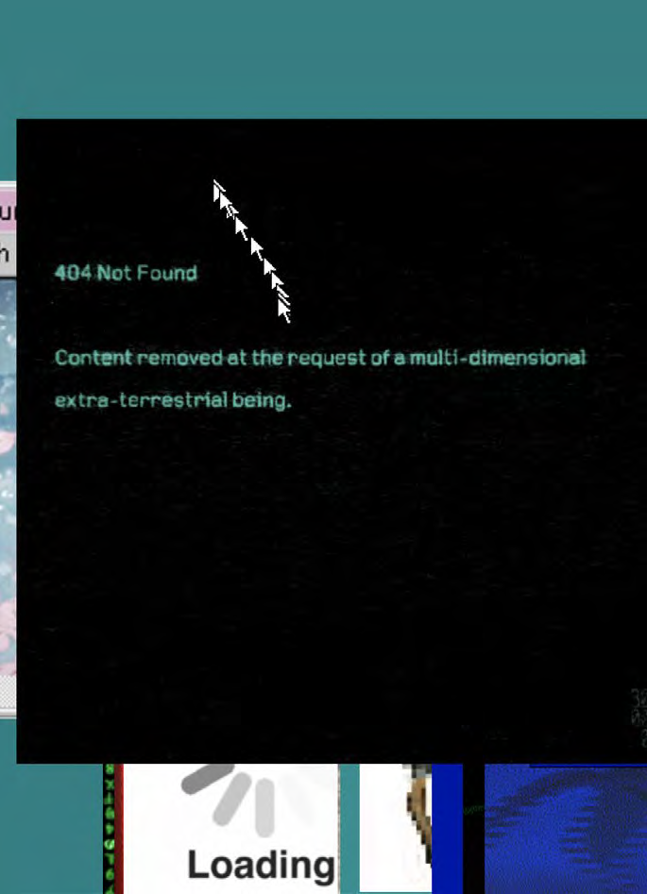

# Net Art

Links from past student works *You may have to allow pop-ups or camera access.*

<https://tornupnegatives.github.io/what-keeps-you-awake/> https://preview.p5js.org/CadenGino/present/MNHy8CuaF https://aemeadow.github.io/adhddemo

## PAREIDOLIA -Lee Oliver

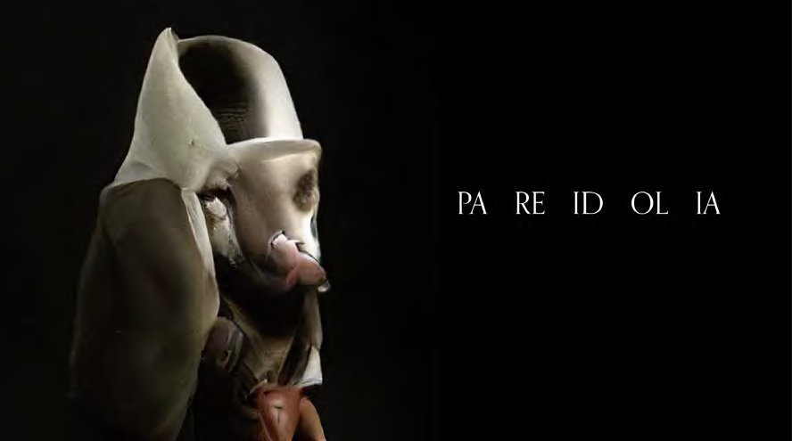“Pareidolia is the tendency for humans to see faces where there aren’t any, like when you stare for too long into paint strokes until people begin to emerge. These images presented here may appear to emulate humanity, but they are simply an illusion dreamt into existence by a computer. Together the computer and I worked to create tens-of- thousands of these beings. I watched the birth of each one and guided the chaotic randomness of each of their children.

It began when I told a computer to learn the word “mask” and depict what it saw. This initial image, a hollow imitation of humanity, gave birth to even more interpretations of the word and even began to learn new words. After thousands of generations, the beings took form and became made from beeswax, violins, coconut crabs, and other words the computer happened to learn, but under my guiding hand, I ensured the word “human” never entered the list. Their human forms are a coincidence, simply digital pareidolia experienced by a computer. There are no humans here. As the genealogy of random words and their depictions evolved into increasingly complex forms, I gave them a voice and asked them to talk about pareidolia. It soon spoke as if “Pareidolia” was the name of a town and chose to give me the title of this installation, “Welcome to Pareidoia.”

-Lee Oliver

See the current net art iteration of the project at: https://[www.pareidolia.guide/](http://www.pareidolia.guide/)

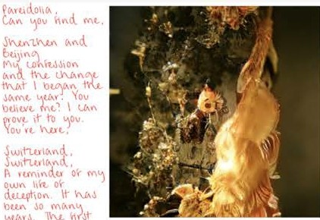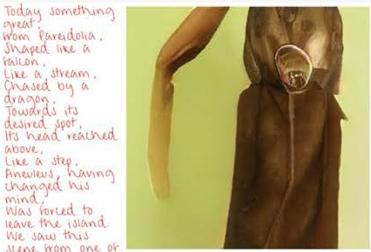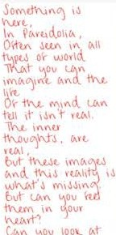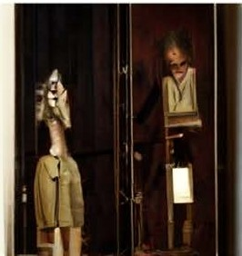

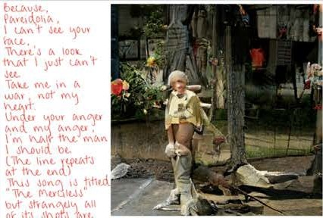

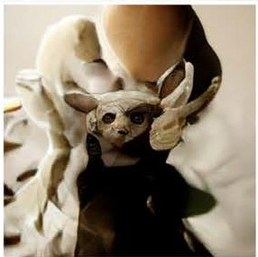C.omt. i"tb

fCA> tiQO\iC\ .

\'JCAtLI'\, *t* l"\.l.

UJI t.l'\O'V..! Ov1

'o•J O"t "-'«11l1CA, ,

Swirl\ '" \'\.,

l\OvO\\'\, 0.-

**1\"\t_Mt,**,r.J

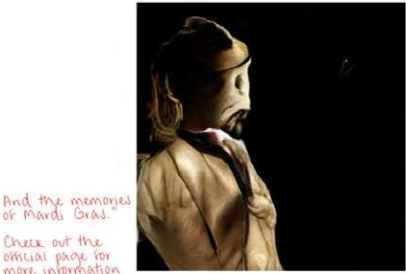'"tu

C.01',tc ,

,u,d.oht..

lII'\ I\"\,(. O'oth "­

\)\vt .

Sl.\vt. 11'\.1 V•""-,

\J.t,(,\l wl"-!\t'

')Ov•· ,

1-\o-j., l"IJ) l., "jOV

**{,\V\Q Mt.,**

Yov\\ '"

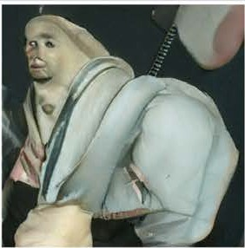VCA, lid.Ohl/\•

Yov', t 1" l){AQ

d.,tt\M \(An().

1"'1. 11-\1.01-,l or

t;,,uu.. V\!Wt iV\J,

d.lh"i C.-nQ l'\1<\'N°

\.li\<l.. o)' th.,"c/\

fl.VO U\. lh...i'

m,r,o, 1J 't\,11 o,

QCA> ll • t,;u;liO"l

I\ ti Oi\01'"\0 C.-> t,

I\1\lr\C\ t'.) Lrl.\Lll t\'\i M'-\.Jt"ti'-\ o·,· t \>"\.I.. too<

LO"JtivtJiO", l)vt·

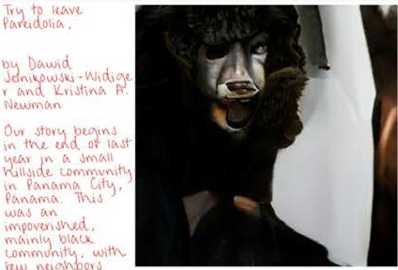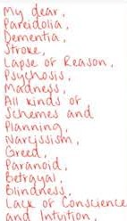

Cc.-n ,t *N.19* .

10 bt, 1n

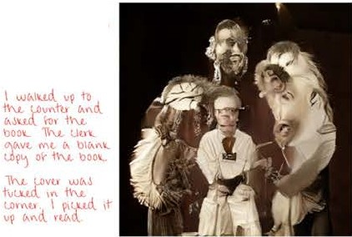

lod.v-';'),, "

fv-vl\l Oh(A , I (AW

I\ 'ou,vhhil c,nd.

I" i\ \ U,Jt I('{\(A t,

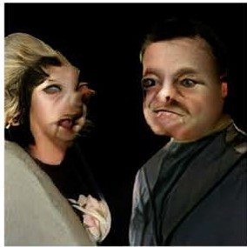

CA,til\OhC.-,

1'\G<-,,1.\ "'"

,....to wt1"") \\'\.1,01'),

ivv.n,,w o Lovt.1

How ov l"\.OU) ,r

U\,Ylt to \)t,

11-\.£,.\ I 1-\.0vld._ "ot

Ul.\Jt. l O IOvt,

I\ \)\(An'<. • ""

**fAtHA,\-.\ ol"'ttA,\vrt..**

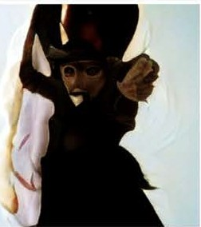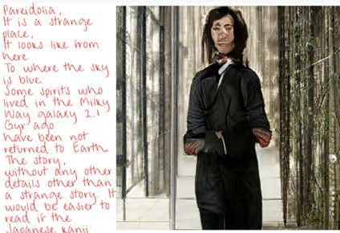

## Circular Crisus - Liliana Rocha

“The cacerolazo as a form of protest comes from a history of resistance. Likewise, it involves the demonstration of power from the use of everyday objects. In this piece, I combine stitching on drapery sheer with the sound of cacerolazos. The circular forms are both illustrations and symbols of the expansion of sound and the object’s presence, in this case, the cacerola (saucepan). I present

a series of soft speakers, which are coils of conductive material wrapped near a magnet that produces an electromagnetic field when an electric current flows through it, and a series of repetitive circular patterns produced by the accumulation of hand stitching.

I expose the sound of cacerolazos as a reiteration of the pulse of my dislocation experience and precarious participation in social- political involvement. I seek to explore the relationship of both physical and symbolic separation. Physical separation includes the geographic separation between myself and my country, and between my home and the street. Symbolic separation includes a

separation between myself and involvement in mobilizations. Could I be more active if I was there? Could I do more? Is my involvement not as meaningful since I am supporting from the distance?”

-Liliana Rocha [Link to Project](https://lilianarocha.art/circularcrisis)

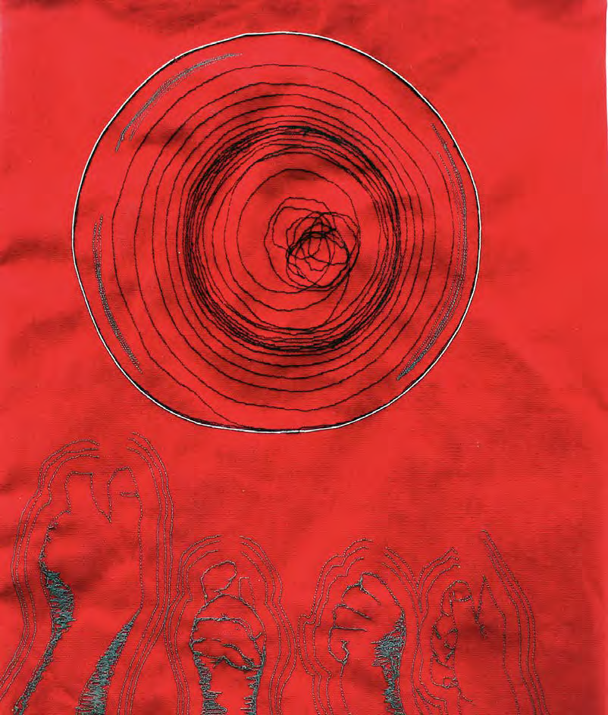 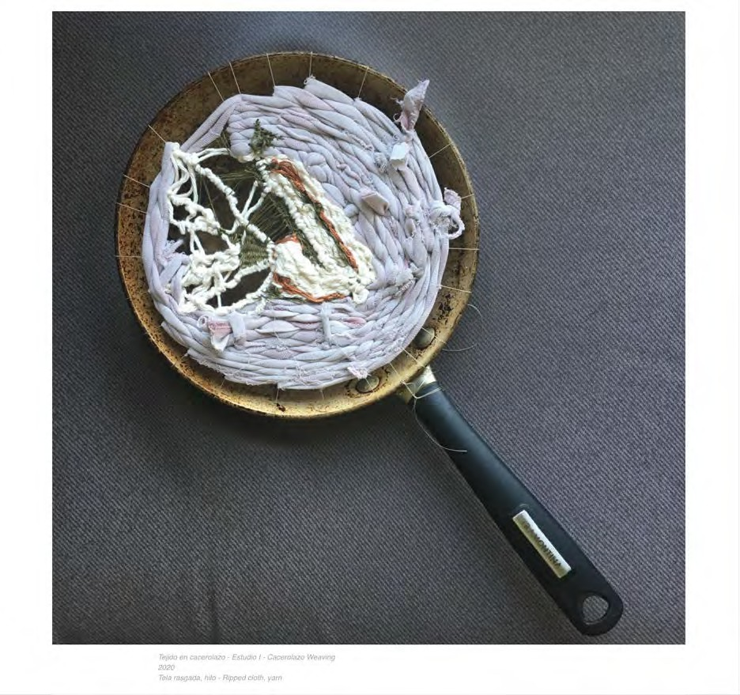

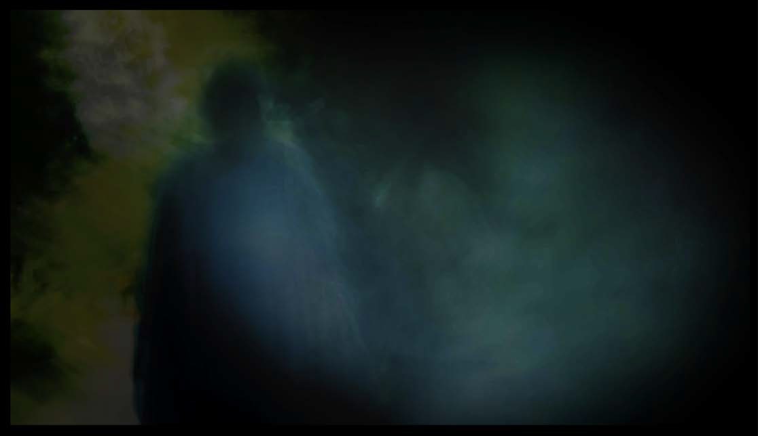

## What Remains Unsaid - Tayla Blewitt-Gray

When someone dies the absence we feel can be for the person alongside the now missing connection, we feel the impact they have on our lives big and small. It can become important to give the bereaved a chance to express their loss— not just directly after

death but weeks, months or even years later. Through the use of the moving image, I have drawn from my own personal experiences of loss to allow others to contemplate how we discuss it.

After losing a long-term family friend Shirley, in 2019 and then my grandmother in 2020, as I became ready to share my experiences,

I discovered many people would clam up. Whether they were uncomfortable or trying to be kind, conversations were brief. I began to realize within my own family we have allowed a space to talk about loss– while at times still difficult it is not taboo. Discussions around grief and death can be difficult, but by allowing an open dialogue it decreases the feelings of isolation that often surround them.

Through video I focus on revealing the ongoing process of grief including how at times it can be invisible, and how we begin to consider the changes in our lives. The visuals are made to represent the slipperiness of memory as we attempt to hold on to what little we might have left. Grief is a common experience that can occur at any point, refusing to allow a space for it to exist can make it worse. Giving space to ourselves, and each other ensures that we can grieve and remember those who have passed.

[Documentation](https://www.taylabg.com/what-remains-unsaid)

## Drifting - Dominick Rivers

“Drifting is an interactive installation with a video art piece, activated by a pressure sensor, serving as the focal point. The piece isolates the viewer from the world in which they were previously; by climbing into the sleeper bunk and closing the curtains, the viewer is shut off from the rest of the world, alone with their thoughts and the passing lights. Though this piece is the physical manifestation of grief, it is not sorrow nor sympathy I intend to invoke in the viewer, but to have them drift along through this journey.

It is fascinating to have recreated an experience during which I imagined myself as emotionally and mentally vacant-- yet in representation became so full. The common thread in my work is rooted in memories of intimate moments which often aren’t shared with the world. These very intense and personal moments are so important as they are the fabric that forms us into the individuals that we are. It is these moments that I want to explore

and allow others to experience. Though this piece emanated from an excruciating personal experience, I don’t believe it should exist solely as a passing phenomenon, but rather for this piece to serve as a mirror to an intensely vulnerable moment where, amidst all of the chaos, tranquility was born.”

-Dominick Rivers

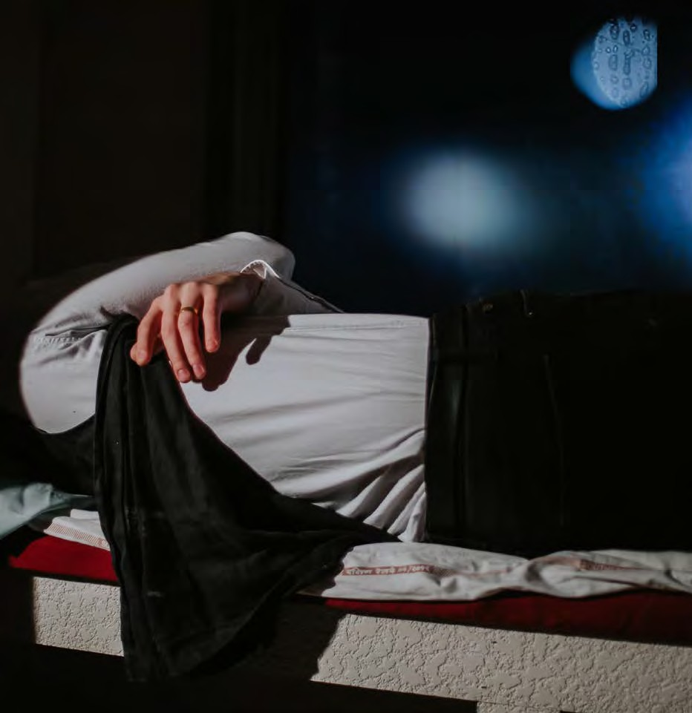 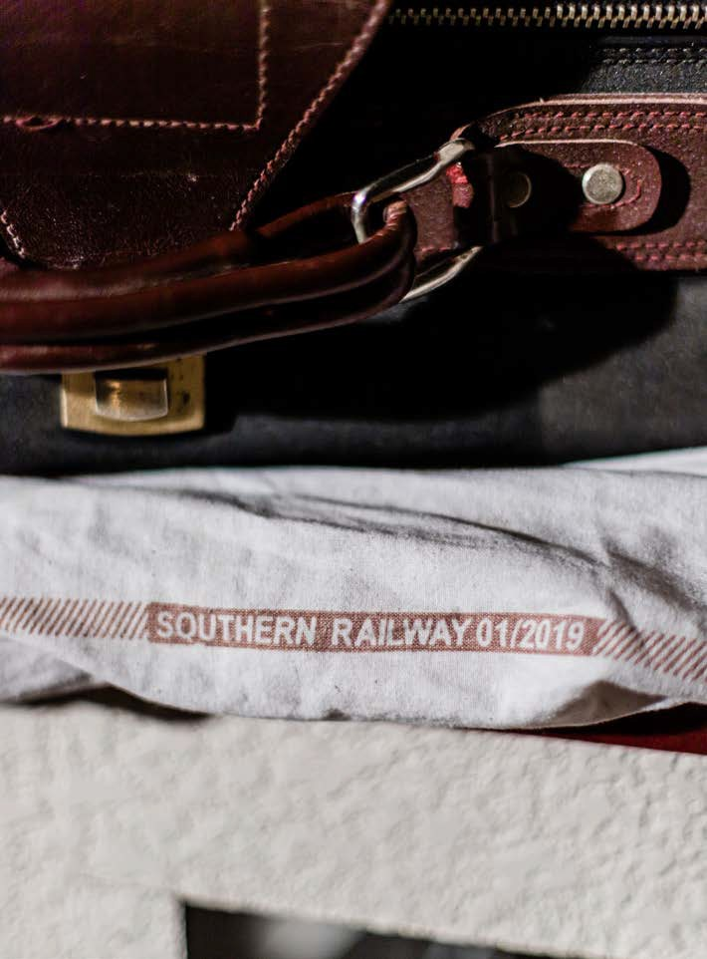

# Ustopia

Project 1: Visual Storytelling using Photoshop

With the rise of digital technology over the last three decades, our relationship to creating and reading images has changed rapidly.

Manipulation of images can be seen in advertising, album covers and artworks, all focusing on using imagery to tell a story. As image making has shifted so has the aesthetics of visual storytelling. In this

project, we will focus on design, and images as tools for telling viewers

a story. Thinking in terms of storytelling we will ask how computer manipulated images distort or enhance a story for a viewer. How do qualities such as scale, light, color, value, and emphasis shift when created through the computer? How do the tools we use influence composition? How do they influence a viewer’s perception of the work or content? Your goal for this project is to explore these questions through Photoshop.

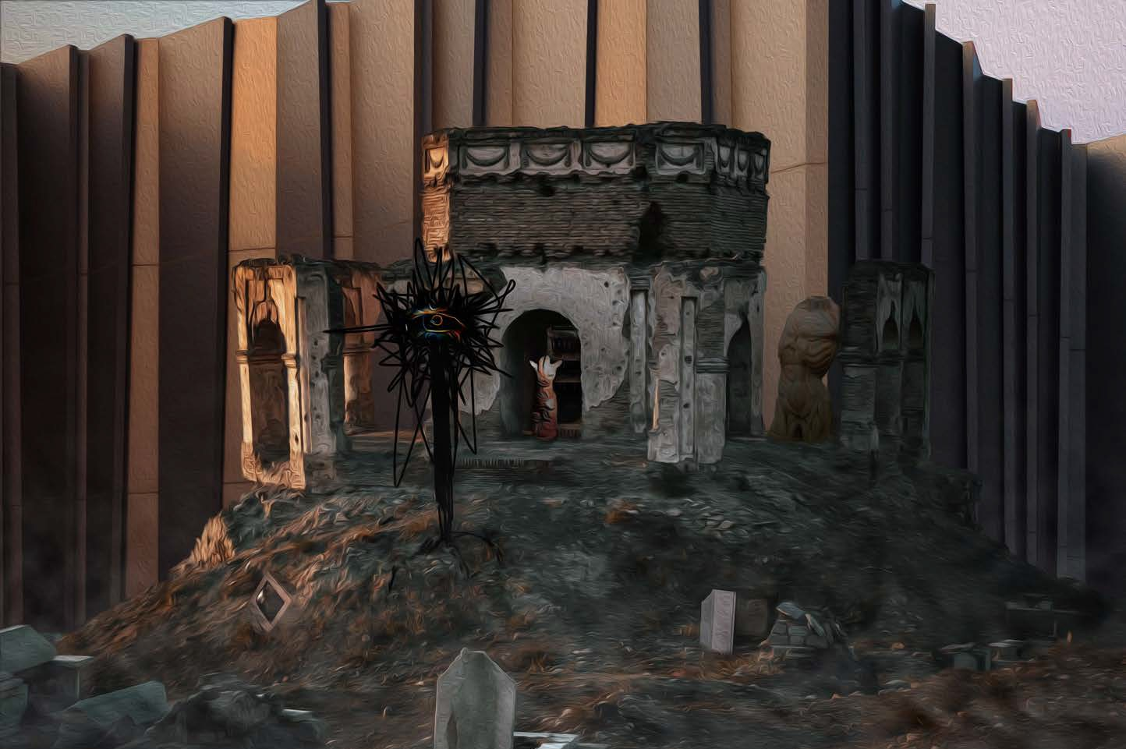

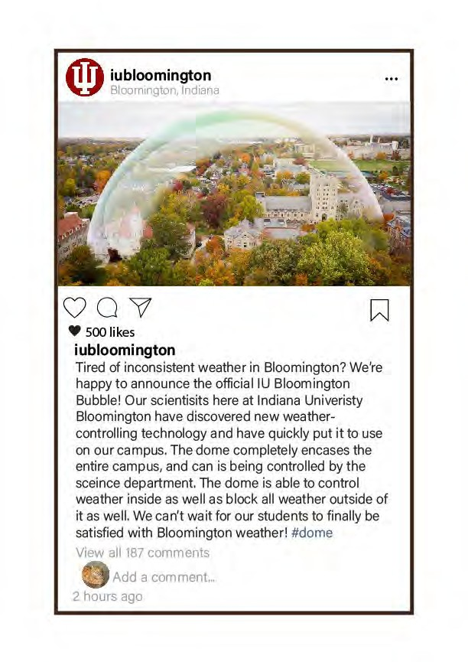

# FakeNews Tactical Media

Social Media is full of manipulated photographs that accompany less than factual headlines. With enough data, Deep Fake videos can now manipulate public figures into saying or doing anything we want them to. This epidemic is not new. Photomanipulation has been part of

the medium since it was invented, however technology has allowed

this false information to spread more quickly than ever before. For this project I want you to use the phenomenon of fake news for good. What if something you thought was wrong in Bloomington suddenly changed for the better. Your project should question how things are by dreaming about how they should be. This can be something on or off campus.

(!) iubloomington •••

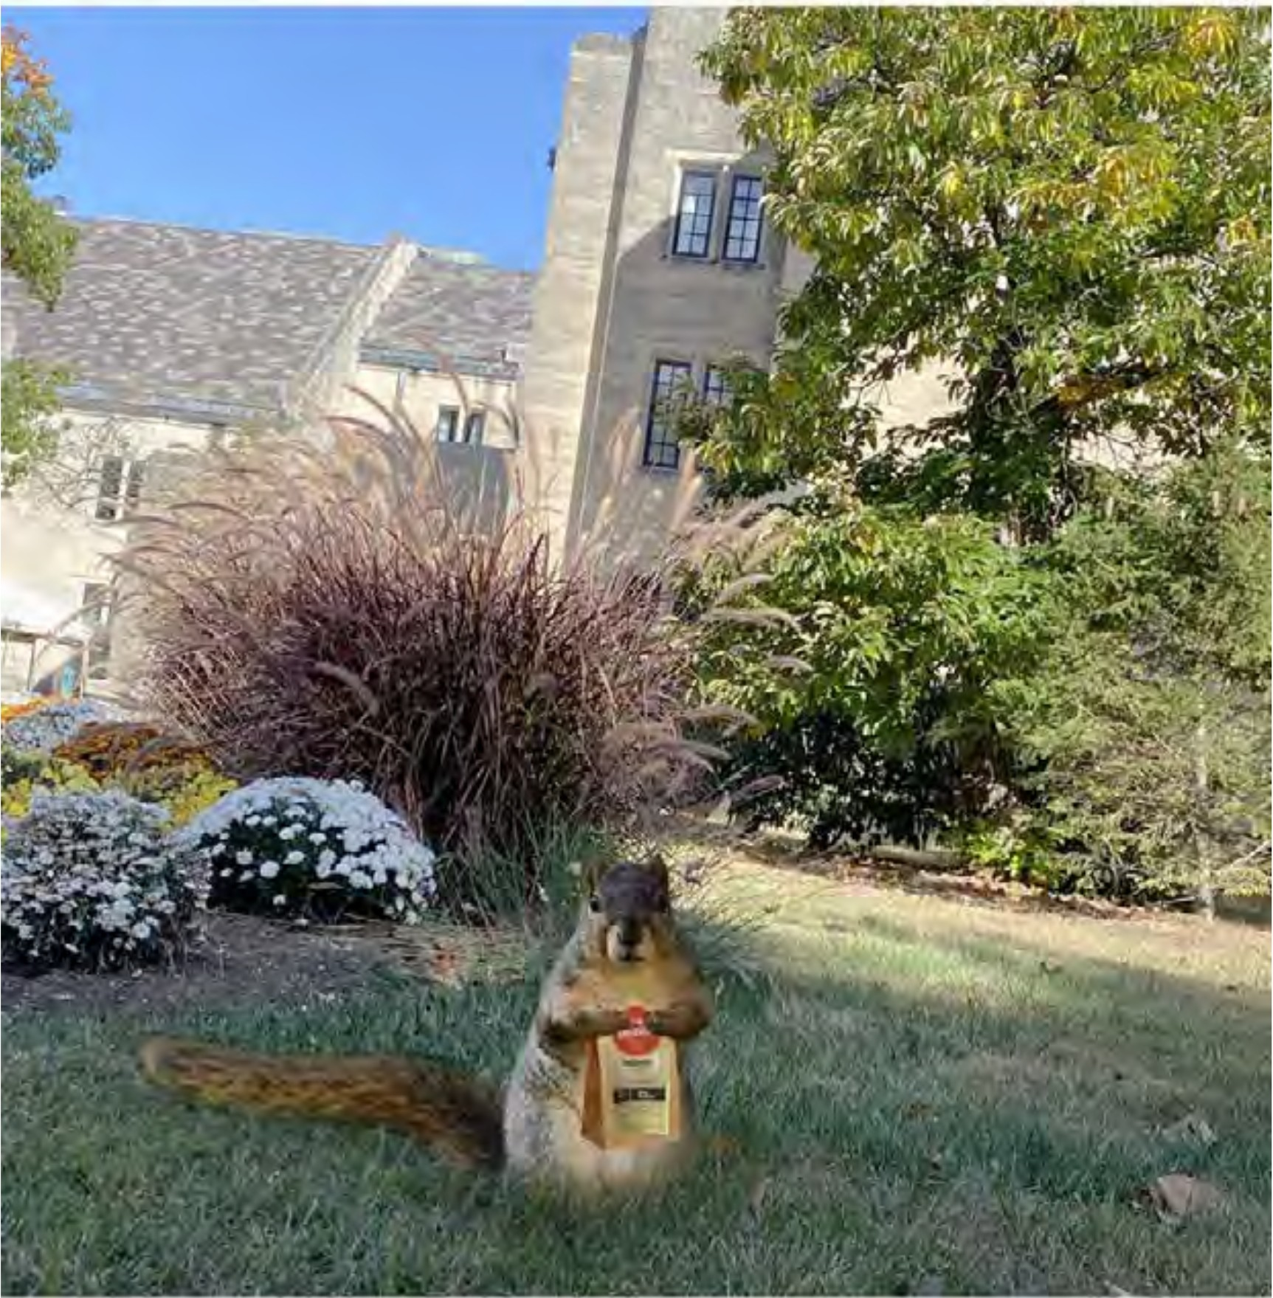

VOV 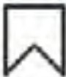

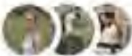 Liked by mcuban and 2,195 others

**iubloomington** We are excited to announce our new initiative

and partnership with the IU Squirrel Club and Grubhub. Because of the overwhelming wait time. typically over 2-hours. at the IMU Starbucks, our campus squirrels will begin delivering to any student in Bloomington through Grubhub starting this Friday! #IU tro1 g J;1nd1anaun1versily

Sep . 1 oer *L*

(!) iubloomington

•••

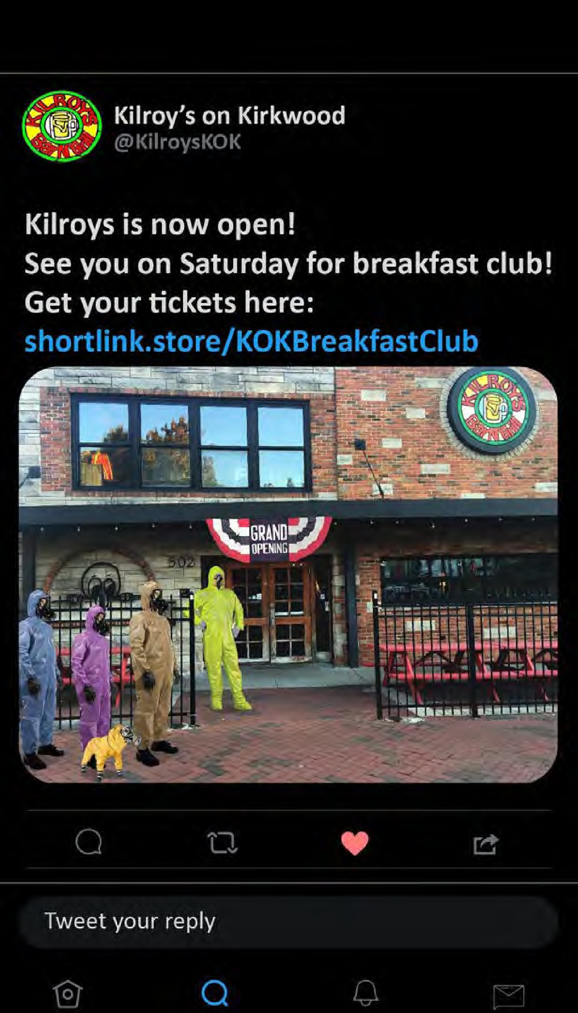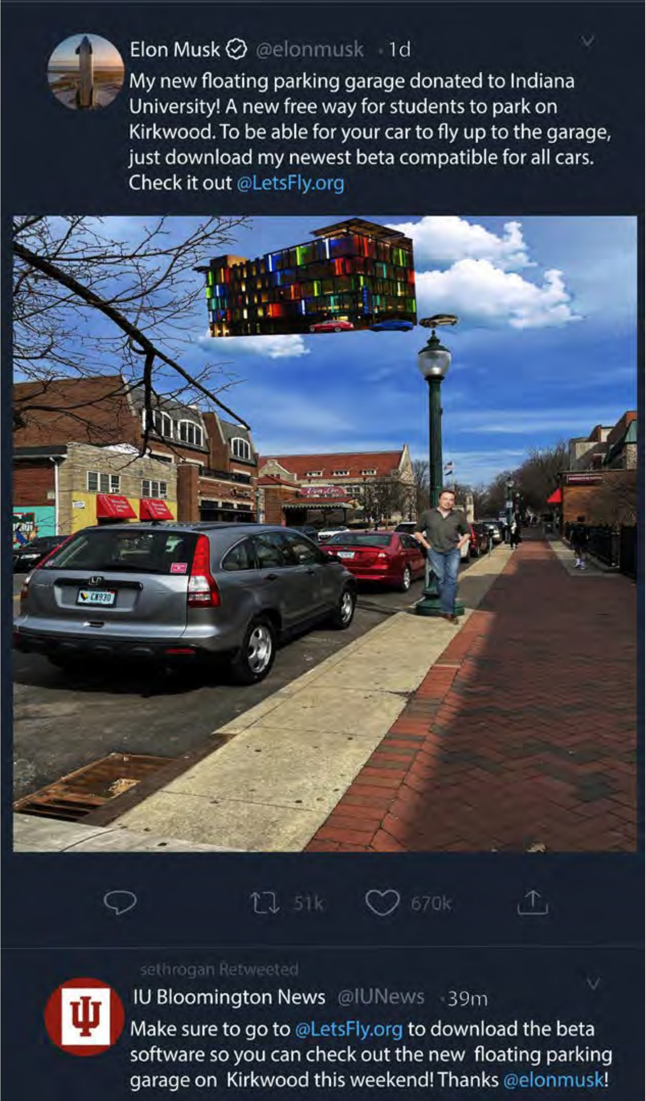

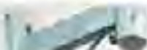 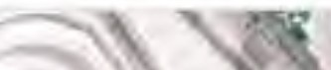

## 2D Design

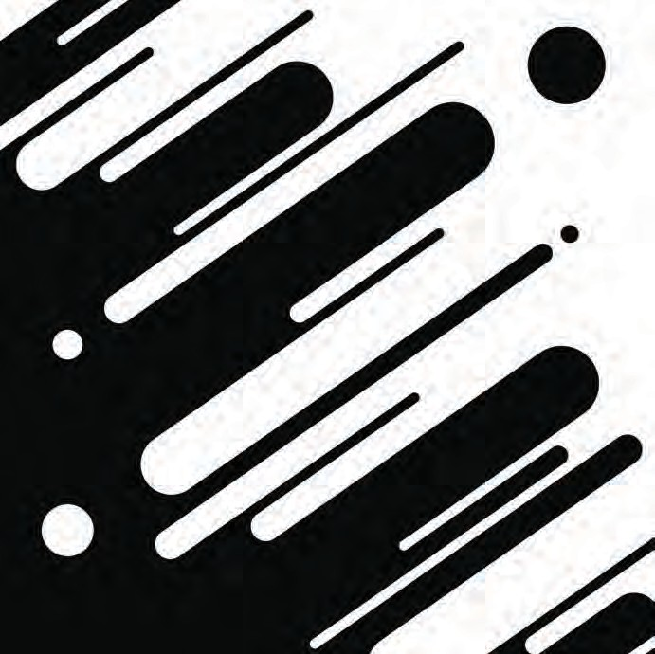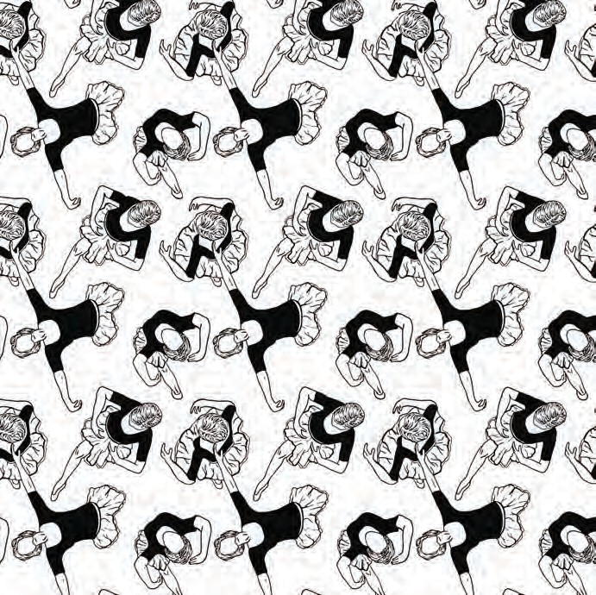

Carrie Kelb, Tension with Type, 7x7, Digital Impact Regular Font, Fall 2017, AD 105 2D Foundations Design

Tony Tan, Positive Negative, 7x7, Digital Print, Fall 2016, AD 105 2D Foundations Design

Isabelle Matthies, Pattern , 7x7, Digital Print, Fall 2017, AD 105 2D Foundations Design

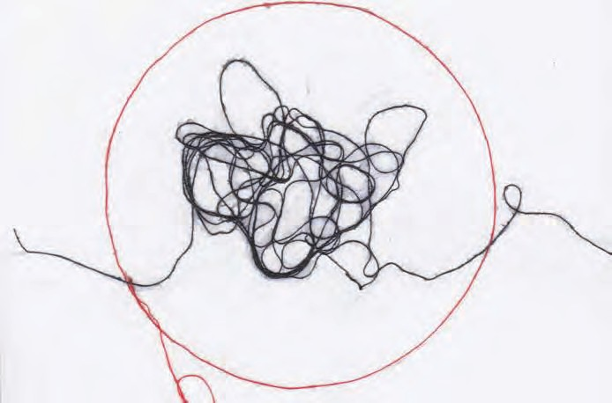Layla Azlan, Line Dialogue, 5x7, Red and Black Thread on Paper, Fall 2017, AD 105 2D Foundations Design

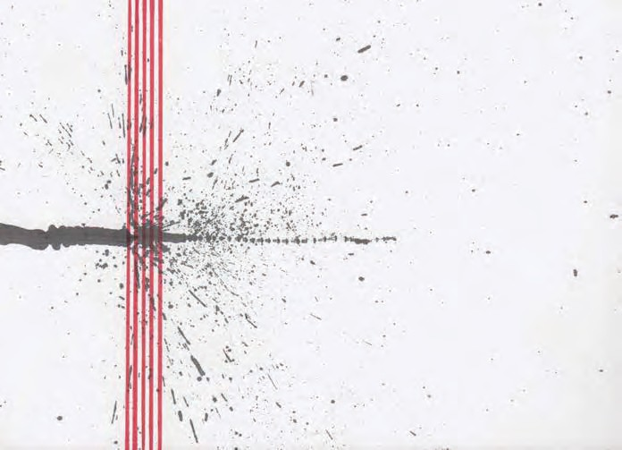

Danielle Conner, Line Dialogue, 5x7, Red and Black India Ink, Spring 2017, AD 105 2D Foundations Design

## Interactive Design

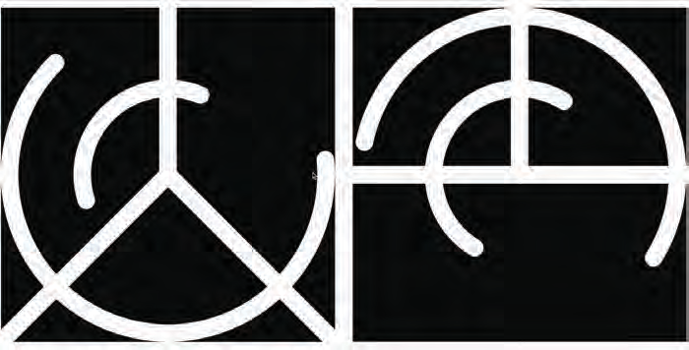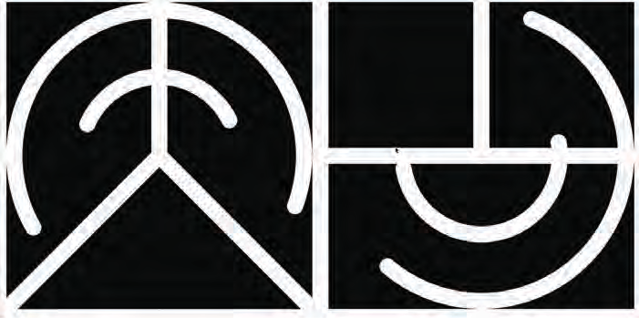

Jiajun Ou, PeaceClock, 4 x 7, Interactive Processing Sketch, Fall 2017, AD 233 Electronic Media Studio

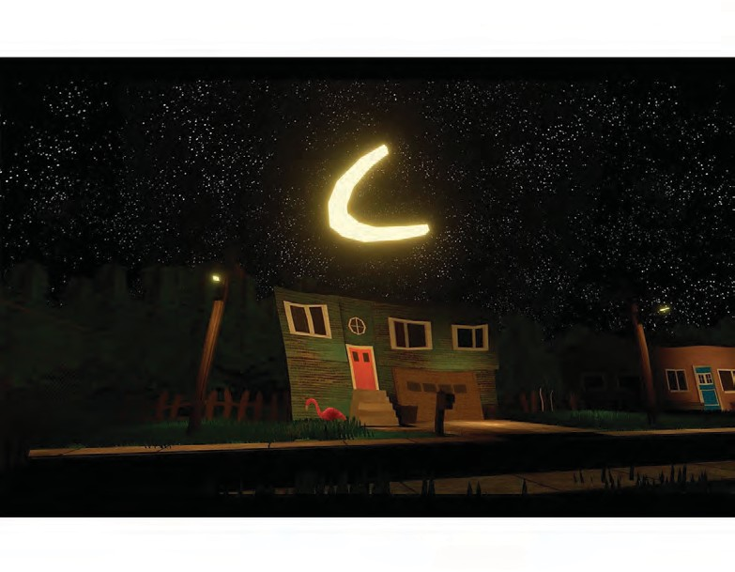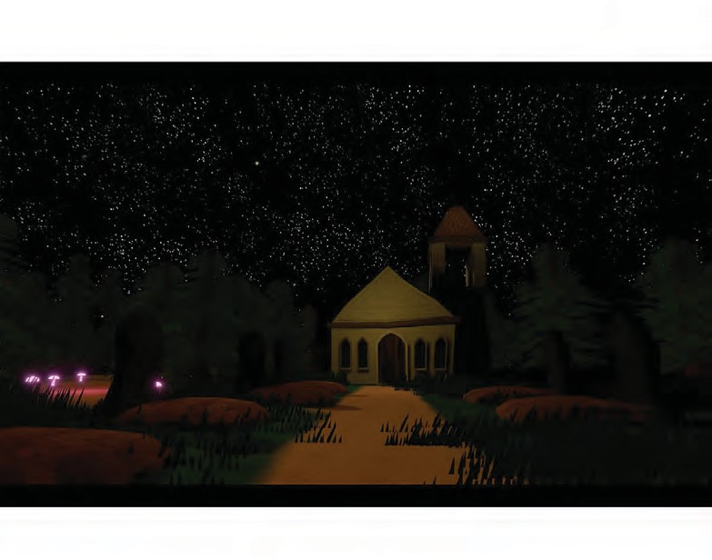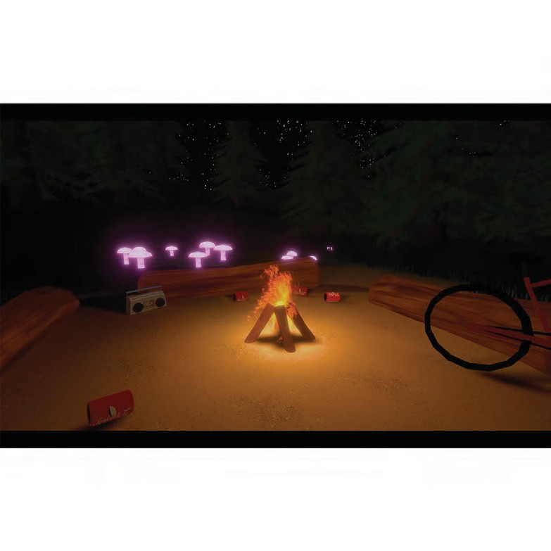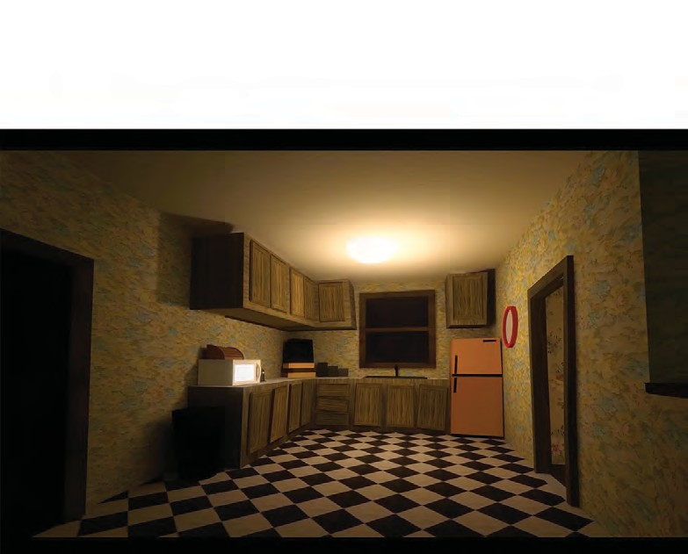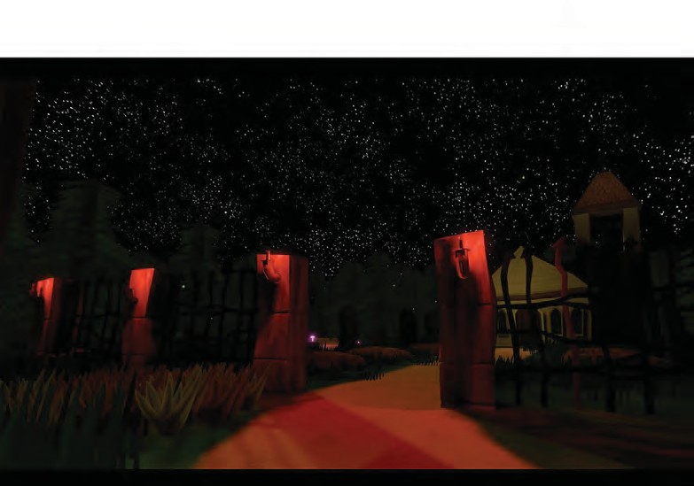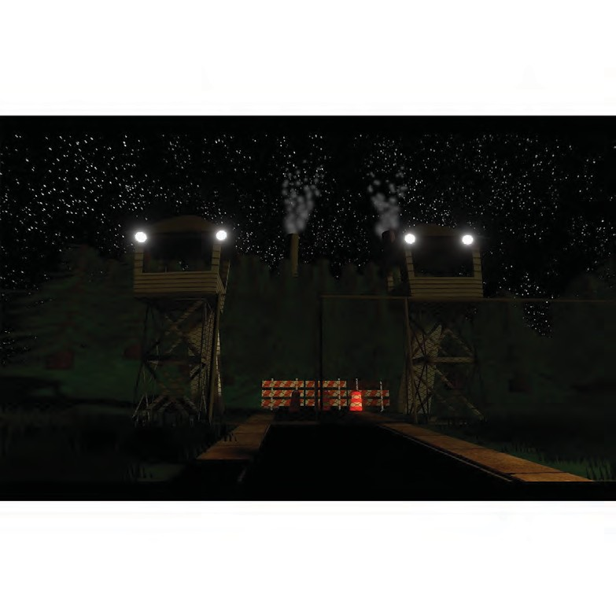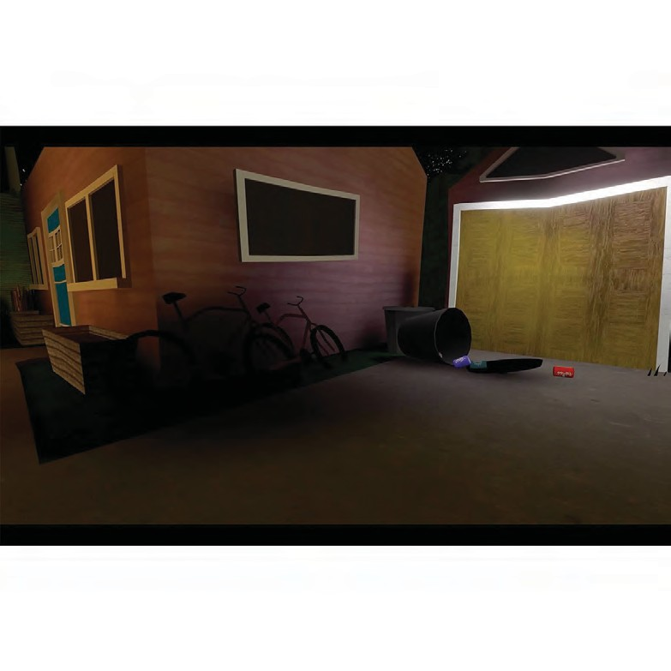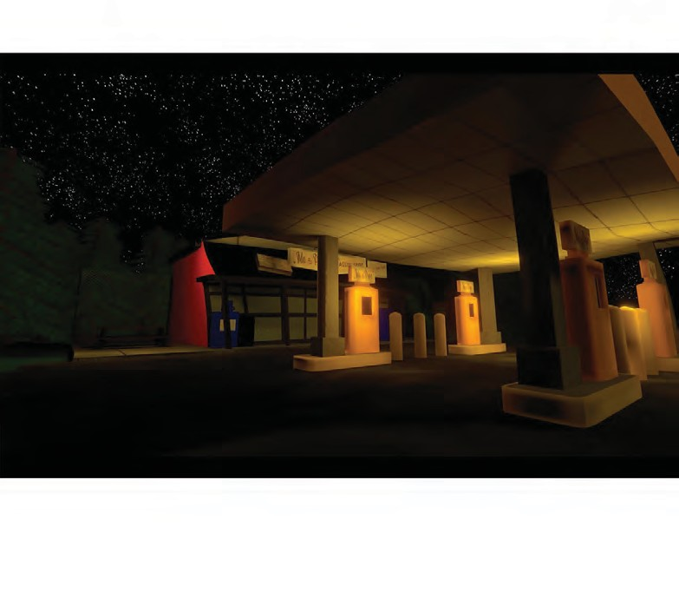

## 3D Environments

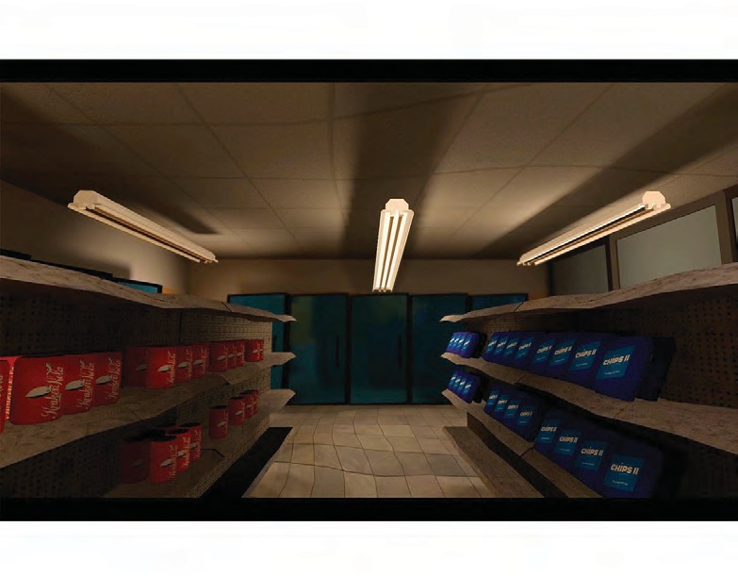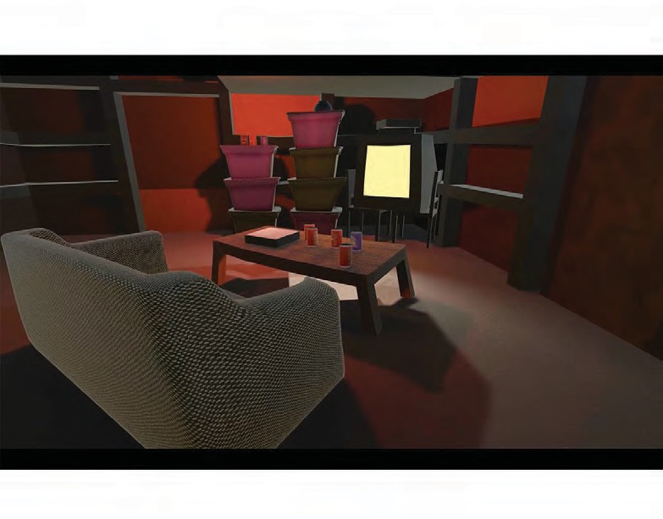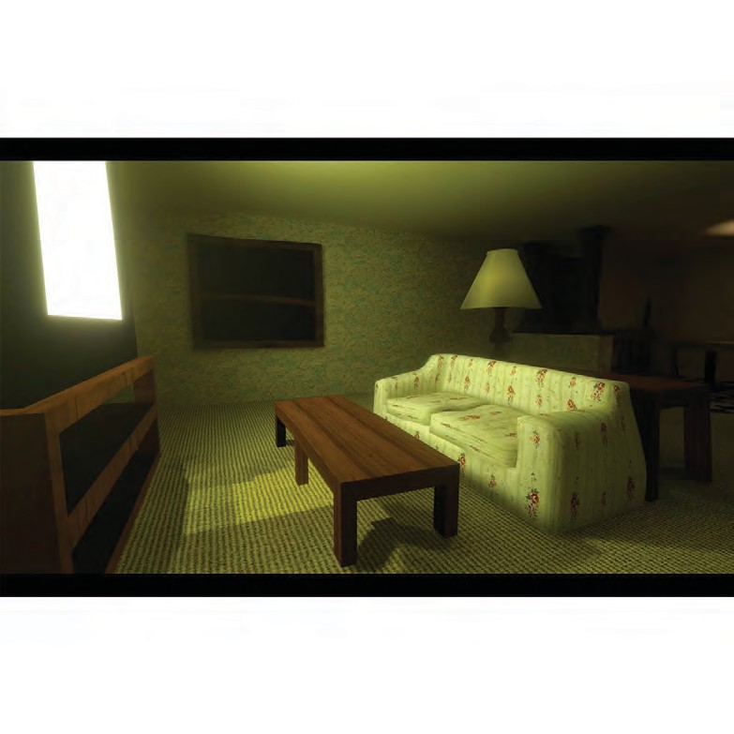

In "A Town Called Familiar", you play as a child in their hometown. Inspired by modern folklore and cryptozoology (the likes of bigfoot, mothman, etc.) and out- sider science, the work focuses on por- traying the world through the lens of a local child experiencing a change in the only town they’ve ever known. A factory has opened nearby, claiming most of the field and woods where the kids played.

The work depicts a critical approach to modern America and the dangers of cap- italism in our culture. These topics culmi- nate in a virtual reality environment and installation that straddles the line be- tween magical projections of imagina- tion and the difficult reality the townsfolk and the environment's subject face in their constantly changing home.

- BFA DEVON FISHER

## Installation Video Goodbye.

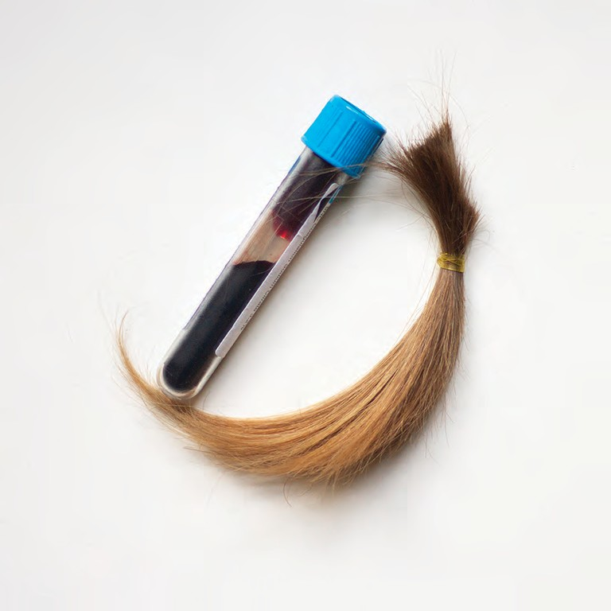Goodbye focuses on my personal experi- ences with death and illness. The creation of objects that are tied to memories be- comes a means for coping with personal loss. My processing of grief and illness is visualized through a series of letterpress printed and hand-dyed silk panels, resin cast relics containing my hair, nails, and blood, and a wall-sized video projection of myself. This body of work aims to bring the topics of death and loss, often private topics, to a public platform, in order to create an open dialogue with those that have lost and faced their own mortality.

.

- MFA BETHANY RAHN

## LOAD-BEARING

An installation of colorful interconnected forms displays a vitality and claims space, breaking free from the restraints or

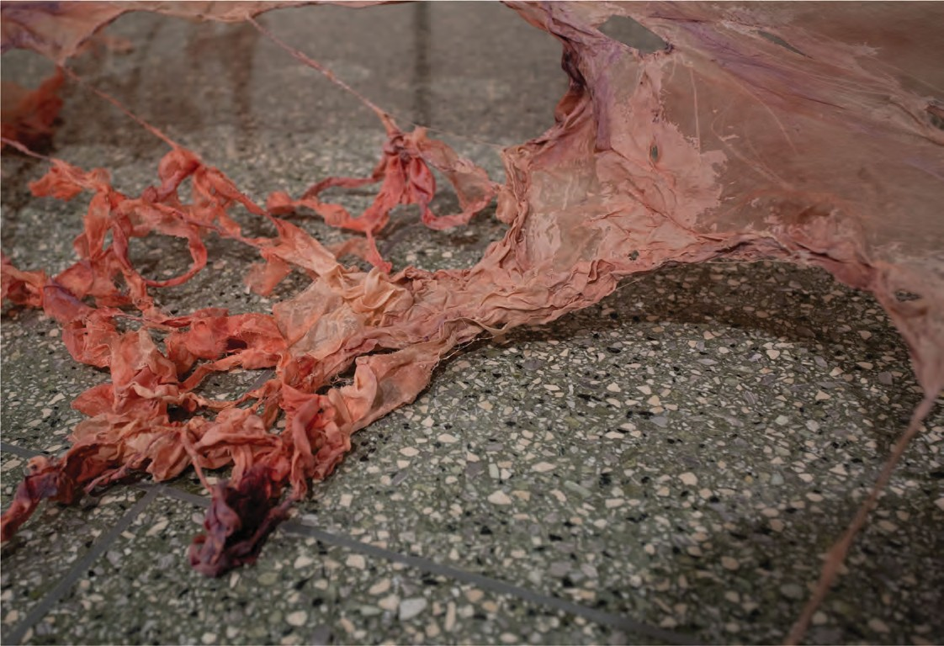frames. Forms are tied together through a web of delicate copper wire and madder roots, two tools of agency over reproduction, suggestive of both the transfer of knowledge and access to healthcare.18 The forms are also connect- ed to vibrant placentas19 and pools of ambiguous liquids (expelled from the body? something to nourish the body? a mess from the child?).20There is much to develop with this visual language and I’m looking forward to continuing to expand materials into visceral textures, refining the integration of maternal forms with ar- matures, and developing a contrast of forms with agency showing a passage of time, action, and reclamation of sustain- able vitality.

- MFA EMILY ZARSE

## Interactive Paintings

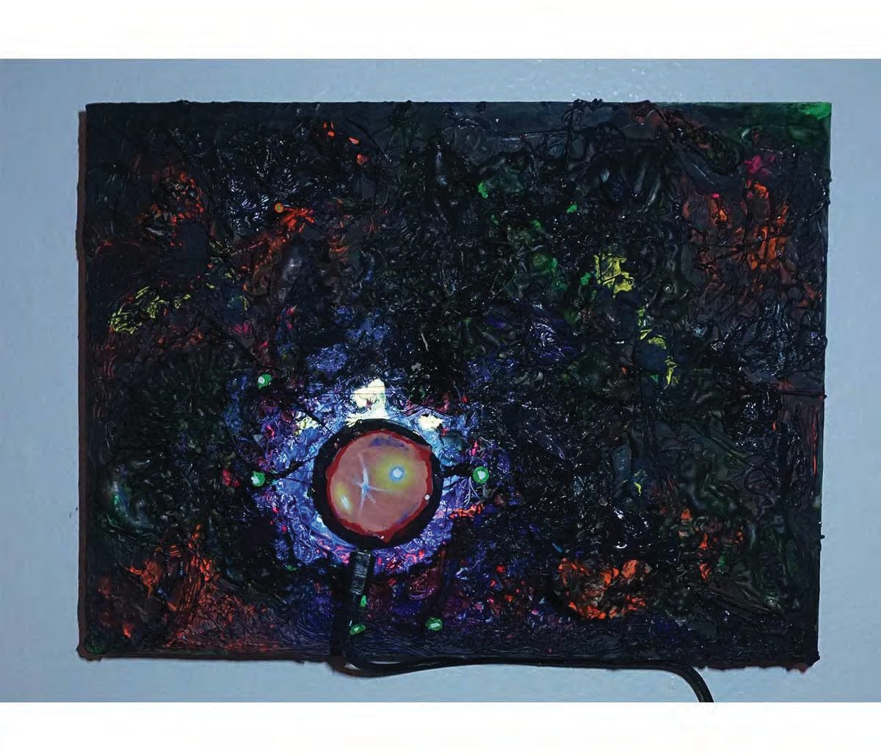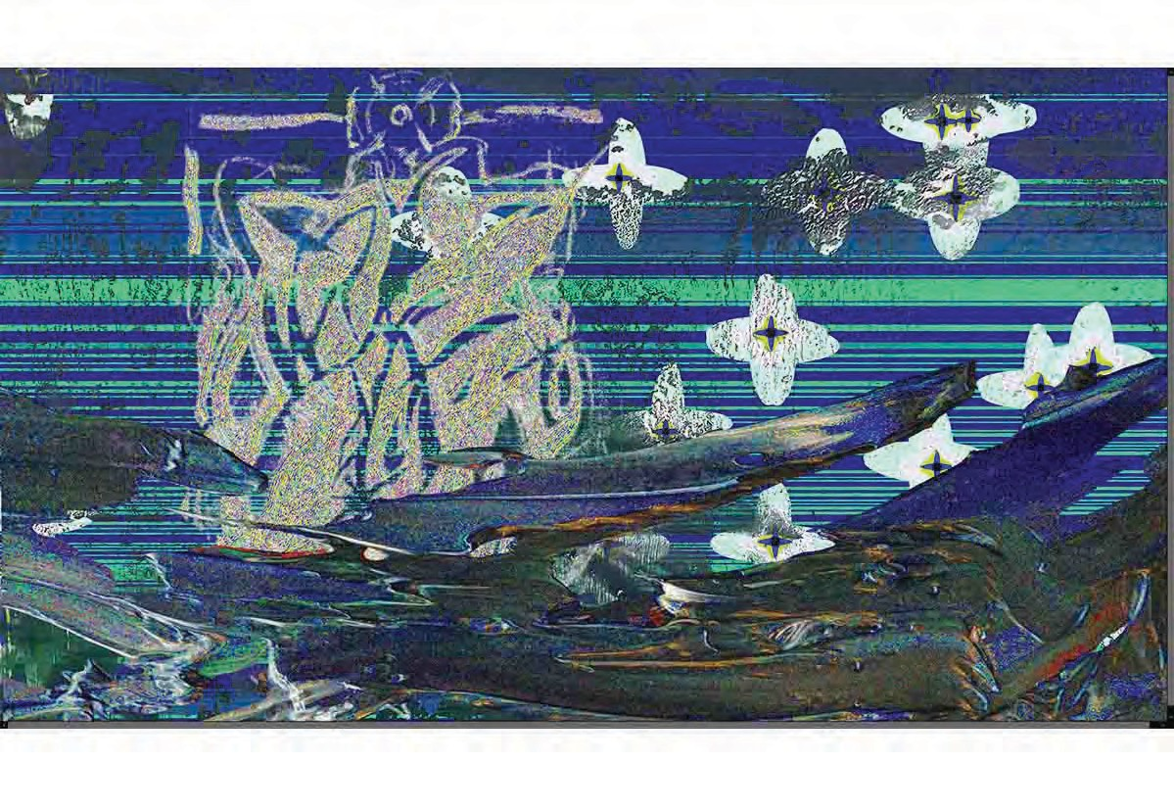

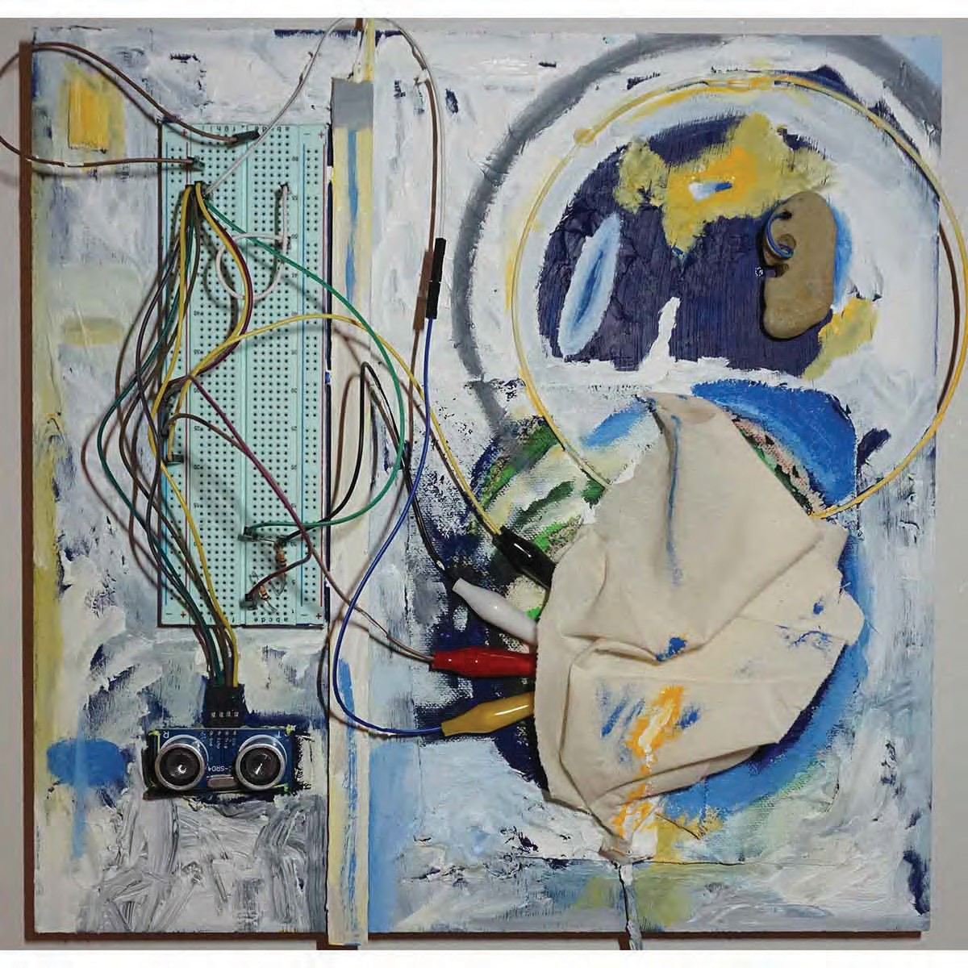In my project will_0_wisp I explore the folkloric concept of the will-o’-the-wisp, a strange phenomena that occurred throughout inhospitable regions of Europe and North America since at least 700 years ago. This concept is the motif that is recreated throughout this series of paintings. Here are traditional wall works, some with electronic hardware or digital- ly printed materials. At the end of the space a monitor displays moving digital paintings. This is built on my practice of combining media from digital and ana- logue disciplines.

I take inspiration from organic forms, such as plants, sea life, and microscopic biology. My own forms are abstracted, and have developed alongside abstract mark making and simple symbolic repre- sentation of human(made) forms, such as eyes, interior spaces/things, or infrastruc- ture. The symbolic forms aim to indicate human presence or perception without a bodily form.

- BFA EZRA ENGLES